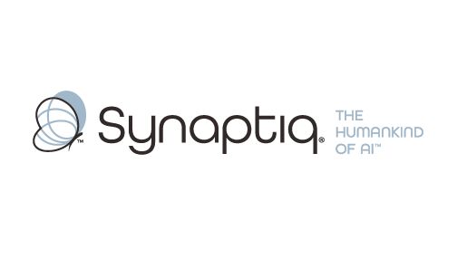
______________________________________________________________________
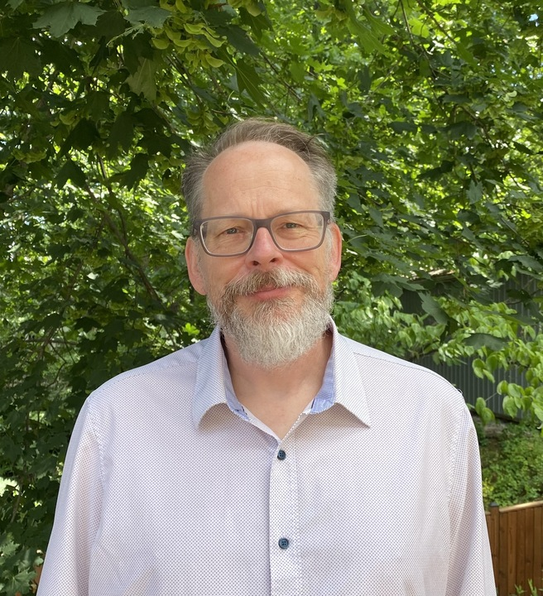 | Dr. Tim Oates  Chief Data Scientist & Co-Founder, Synaptiq  AI Strategy & Workforce Transformation | "The Humankind of AI"

Overview
Dr. Tim Oates is a distinguished AI and machine learning expert with over 25 years of experience delivering practical computer vision, document processing, and RAG solutions across a wide range of organizations. As Chief Data Scientist at Synaptiq, he specializes in guiding organizations through strategic AI initiatives, having led implementations ranging from machine vision systems for quality control and safety monitoring to sophisticated document processing pipelines and retrieval-augmented generation architectures. His recent consulting portfolio includes computer vision deployments for construction site safety and patient medical images, advanced document processing systems handling diverse formats, and RAG system optimization with proven evaluation frameworks. Tim's approach combines rigorous technical expertise with deep understanding of operational realities, helping teams avoid common pitfalls while identifying high-impact use cases across both visual and textual AI applications. His 150+ peer-reviewed publications and hands-on consulting experience uniquely position him to architect AI solutions that drive sustainable value in complex enterprise environments.
Background & Expertise
Dr. Tim Oates is a seasoned AI and machine learning leader with over 25 years of experience translating cutting-edge research into practical business transformation across computer vision, document processing, and enterprise AI architectures. As Chief Data Scientist at Synaptiq, Tim specializes in guiding organizations through strategic AI transformations, with expertise spanning machine vision deployments, sophisticated document processing pipelines, and retrieval-augmented generation systems that deliver measurable business value in manufacturing and industrial environments.
Tim's recent consulting portfolio demonstrates comprehensive expertise across the AI spectrum. His projects include implementing machine vision systems for construction site safety and productivity optimization at a global construction firm, developing quality control and defect detection systems, architecting advanced document processing systems that handle diverse format types (PDFs, structured data, unstructured text), and designing RAG pipelines with optimized retrieval quality across varying use cases. This hands-on experience across both visual and textual AI applications gives him unique insight into where AI delivers real ROI versus where organizations commonly over-invest or under-scope their initiatives.
Prior to his current role, Tim served as Chief Scientist at CircleBack (now SalesIntel), where he pioneered AI-driven information extraction and management systems, overseeing the development of entity extraction, linking, and resolution algorithms that processed millions of documents at scale. This experience in building production systems that ingest, structure, and retrieve information from diverse sources, combined with his computer vision implementations, provides a rare perspective on architecting scalable AI solutions that handle complex data ecosystems with precision and reliability.
As an Oros Family Professor of Computer Science at the University of Maryland, Baltimore County, Tim has authored more than 150 peer-reviewed publications covering computer vision, natural language processing, machine learning, and industrial applications. His dual perspective as both researcher and practitioner enables him to help organizations navigate AI implementation challenges while focusing on applications with proven business impact. Tim holds a Ph.D. and M.S. in Computer Science from the University of Massachusetts, Amherst, where his foundational work continues to inform his practical approach to AI strategy and implementation.

